Accessible London Map

Project Final Report

       LIS9721/9821 & CS9639: Information Visualization

        December 4th, 2019

   Arnett, Michelle., Khan, Faryal., Kuznetsov, George., Stubson, Liam.  

**Executive Summary:**   
Our information visualization application seeks to bring a solution to the problem of the dearth of information on accessibility in London, ON. Currently, individuals with disabilities cannot conveniently access information on what types of stores, restaurants, buildings, parks, pathways, etc. in London, ON. have accessible features. There is a lot of information about accessibility, but it is not contained in one comprehensive form and some of it is not easy to understand in its current state (i.e. computing slope of sidewalks). While there are other applications that seek a solution to this problem, their scope is limited to certain features, and does not satisfy the needs of our target audience in their entirety. Our target audience is individuals with physical disabilities using wheelchairs and other mobility aids to get around. The scope of the application is to represent a large amount of data regarding accessibility in London, ON., in a way that will allow individuals with accessibility issues to find places they can visit without concern of access. The data that we have incorporated into this application allows users to access information regarding accessible pathways and routes, accessible buildings (including businesses, banks, restaurants, schools, etc.,), and accessible public spaces and parks. Users are not only able to identify accessible places, they can also view crowd-sourced reviews, busy or otherwise dangerous areas (where steep slopes are present), slope and terrain details, and accessibility comparisons between different neighbourhoods in the city. This is an effective and easy-to-use application for those with accessibility issues as it not only allows them to distinguish between desirable and well-suited locations for their needs, it also allows them to determine the best route to get there.

## Visual Marks and Variables

1. Multidimensional Icon

|  |  |  |
| --- | --- | --- |
| Visual Mark | Variable | What it encodes |
| Water |  | This icon encodes a geographic point on a map. This is a conventional abstract representation of a pointer on a map, as observed in Google Maps. |
|  | icon | This icon encodes availability of at least one accessible feature. It distinguishes accessible locations from non-accessible locations. It is analogic in that it represents someone on a wheelchair, however, its utility for our design is in its conventionality as the symbol for accessibility. |
| Water | Size | Rating of the location. |
| New Wheelchair | Colour hue | Type of location i.e. restaurants, businesses, public spaces, parks or shops. |
|  | Colour Intensity | Rating of the location *relative* to the selected filter. This encodes the places that fall outside of the range selected for ratings. The more intense the colour, the closer it is to the desired query. |
| Water | Outline | Distinguishes crowded accessible places from non-crowded ones. |
| New Wheelchair | Outline Size | How crowded an accessible location is. |

1. Lines for routes (on the main map)

|  |  |  |
| --- | --- | --- |
| Visual Mark | Variable | What it encodes |
|  |  | Ideal route from present location to the location selected |
|  | Colour Hue | Distinguishes a route that requires caution from a safe one. |
|  | Size (width) | The degree of steepness of the slope. |

1. Lines (from the Compare visualization)

|  |  |  |
| --- | --- | --- |
| Visual Mark | Variable | What it encodes |
|  |  | Connects properties of one of the locations selected for comparison. |
|  | Colour Hue | Distinguishes locations selected for comparison. |

1. Dots (from the Compare visualization)

|  |  |  |
| --- | --- | --- |
| Visual Mark | Variable | What it encodes |
|  |  | The dot encodes the number of nearby accessible locations (property). It identifies, with precision, the magnitude of this property on a radial coordinate system. |
|  | Colour Hue | Distinguishes locations selected for comparison of this property. |

## Visualizations

**Main Map (1)**

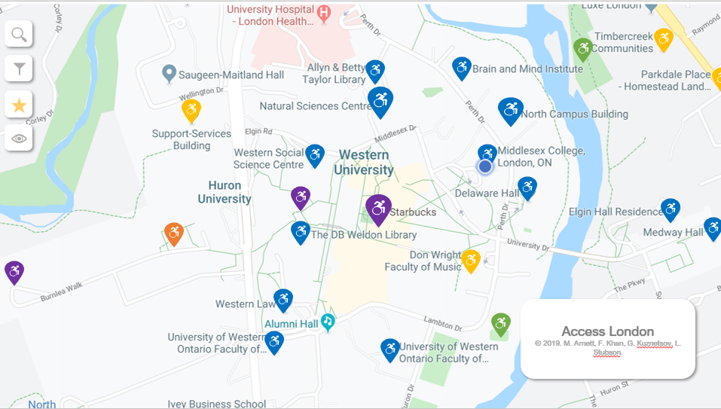

Pattern blending: *VR*1 ∈ []

In the main map visualization, our intent was to identify accessible places geographically from the general, non-accessible ones, so we used the multidimensional pointer icon as a Token (TK) on a geographical map of London (area). This is a high-fidelity map and provides a measure of the relative distance between all locations. Moreover, it also uses absolute (non-relative) information about each coordinate point, so it was important to keep the general cartographic coordinate system (CR).

**Main Map (1) with Rating Filter(1.2)**

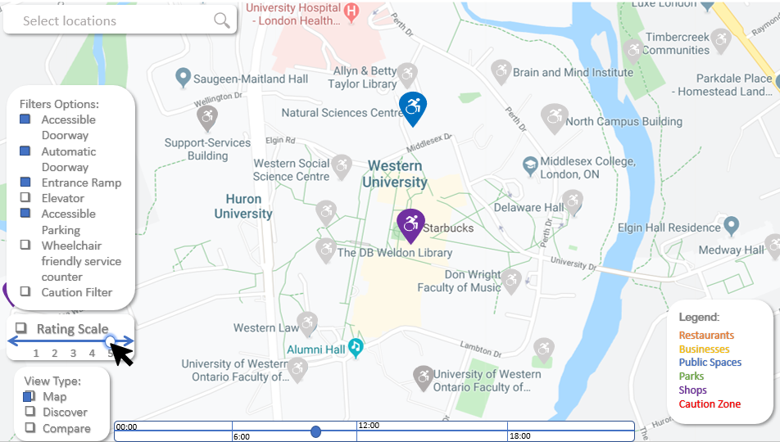

Pattern blending: *VR*1.2 ∈ []

Most of the filtering options tend to include or exclude places, and represent this by the appearance or disappearance of the icons of eligible places, showing the desired subset. However, filtering by ratings allows the user to see even these non-desired places in shades of grey (SP). The colour intensity of the icons varies according to proximity of the locations’ ratings to the rating range selected (as opposed to the absolute rating).

**Main Map (1) with Cautionary Filter (1.3)**

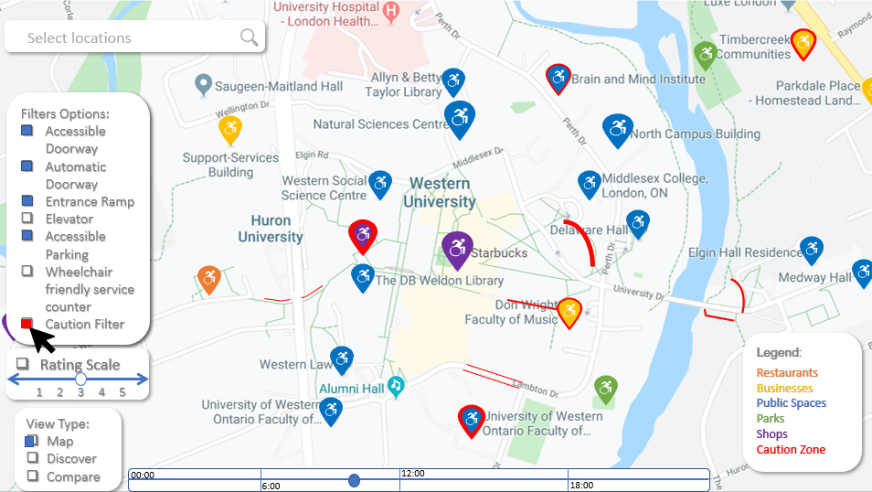

Pattern blending: *VR*1.3 ∈ []

The purpose of the cautionary filter is to highlight unsafe places. With the cautionary filter on, the main map VR now also represents properties that make places or routes unsafe.

In addition to crowded places, indicated by the same icon with an additional dimension i.e. outline, this visualization will indicate unsafe paths through lines. The paths are considered unsafe because of the slope i.e. the change in elevation between points, so they are represented by lines showing the fusion (FS) of these points.

**Main Map (1) with suggested route (1.5)**

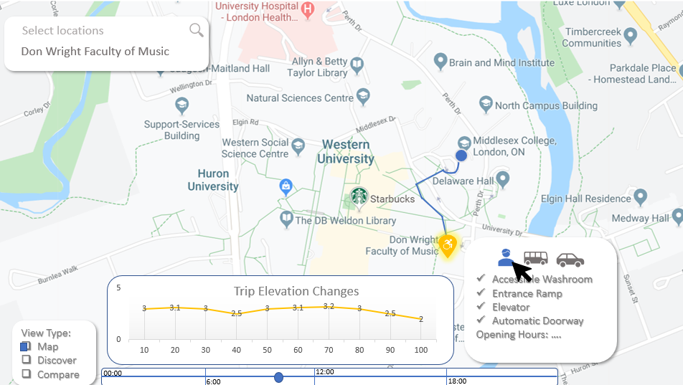

Pattern blending: *VR*1.5 ∈ []

When suggesting the ideal route, we not only want to show that two locations are linked (LK), but also want to represent the precise route i.e. the continuous collection of coordinate points (FS) that will connect the two locations.

While suggesting the ideal route, the visualization system also needed to display changes in elevation throughout the trip. This is represented through a plot of the trip (FS) where the x-coordinate was distance travelled in the trip and the y-coordinate was the elevation (CR).

**Main Map (1) with Cautionary Filter(1.3) and suggested route(1.5)**

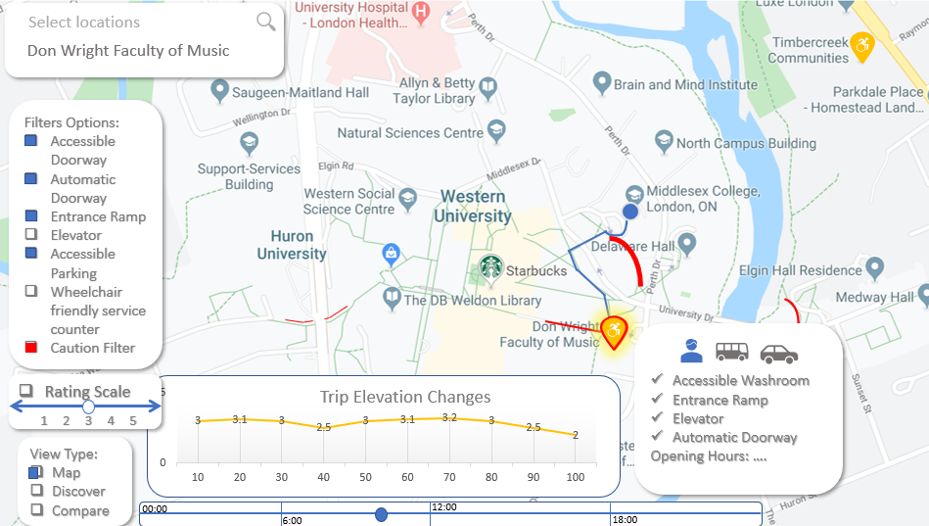

Pattern blending: 1.3+5 ∈ []

This combines the last 2 visual representations, so the patterns observed remain the same as *VR*1.5.

**Discover (2)**

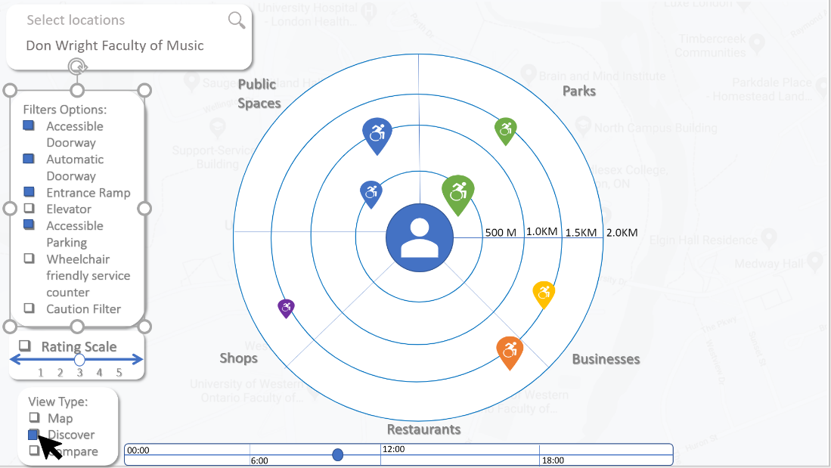

Pattern blending: 

Second visualization called “Discover” inherits multidimensional pointer icons (TK) from the main visualization to encode and represent accessible places. Instead of utilizing geographical map, we provide users with information about distance to places of interest in relation to his\her current position, visualizing those in the area (AR) surrounding “user” token. It is a low-fidelity visualization, its main purpose is to encode information about accessible places in a certain area. Main circle is divided into a few sections representing types (GR) of accessible places currently selected and each concentric circle represents distance in radial coordinate system (CR) from the user’s current location. Together they form cells (CL) within which tokens are grouped by distance and type.

**Compare (3)**

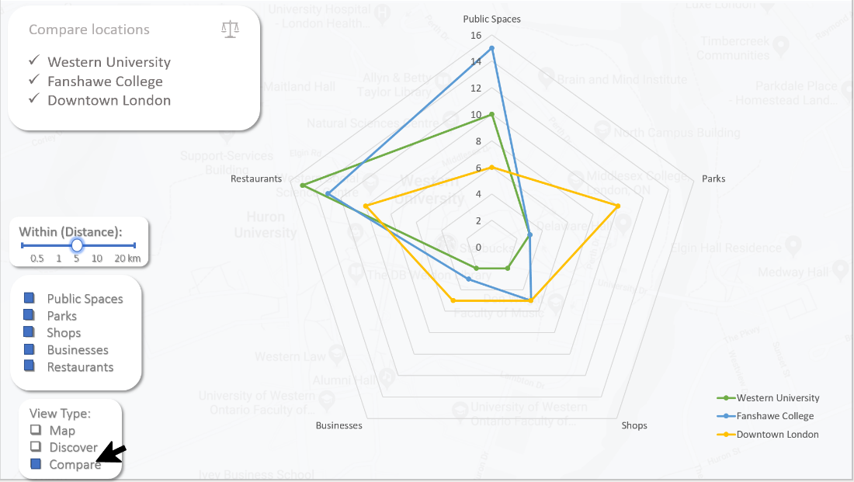

Pattern blending: 

Third visualization is called Compare. It is a low-fidelity visualization in the form of Star plot (or web chart) and it serves a purpose of encoding information about quantity of places of a selected type in a particular area. Each shape (AR) represents an area of interest and consists of several linked (LK) nodes. Position in relation to the center of the plot (CR) of its nodes (TK) represents quantity of places of respective type in that area. Those shapes stacked (ST) on top of each other for comparison.

## Interactions

The following are the interactions that our visualization system facilitates.

Filtering:

We wanted to represent accessible routes and places, as well as, their properties, comprehensively, so that people may analyse their choices in detail. Due to the density and scope of the information represented, the visualizations have several filters to arrive at your desired subset of locations.

Both the low and high-fidelity map visualizations allow the user to filter and represent a select subset of places and routes by the following criteria: types of location, accessible amenities, rating or time of the day.

Selecting:

The user can select a location by searching for it or by finding it on the map and clicking in it. This will allow the user to access more detailed information regarding the location.

The selection of a location also unveils the subsequent selection of the mode of transportation, that will provide you with the ideal route according to your choice of the options.

Searching:

All the visualization systems enable the user to search for locations through the word-search box. The high and low-fidelity maps both allow the user to search by navigating the map and finding the locations spatially as well.

Navigating:

Since the information space is significantly geographically and spatially oriented, users should be able to navigate about the map. The visualization system will use a geographical map underlay – preferably that of Google Maps– so it will include its general wayfinding and navigational elements, such as zooming in and out, and dragging the map to see the context.

Drilling:

This occurs on selection of locations. For the locations selected, a pop-up box appears with further details about the location, as well as, the options for selecting modes of transportation for routes. Both of these pieces of information are hidden in the default view of the map visualizations and are revealed only on selection of the location.

Comparing:

Third visualization is dedicated solely to this action. By encoding accessibility information into shapes and stacking them on top of each other we provide user with a comparison of different areas.